Announcements

Good morning. It is Wednesday, November 24, 2021

Please pause for a brief moment of silence…

Please rise for the Pledge of Allegiance…

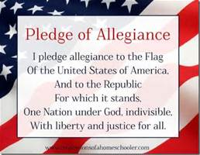
The half day schedule is as follows:
Date: Wednesday, November 24, 2021
7:25-8:15 | Period A
8:20-9:08 | Period EF or FG
9:13-10:01 | Period GH or HI
10:06-10:30 | Period J

Coffee House will take place Wednesday, Dec 8th 7-9pm in the Library. Sign up sheet is outside Mr. Jordan’s room which is M19. You can also sign up online in your google classroom.

We hope you all have a nice Thanksgiving!

