Announcements

Good morning. It is Wednesday, November 17, 2021

Please pause for a brief moment of silence…

Please rise for the Pledge of Allegiance…

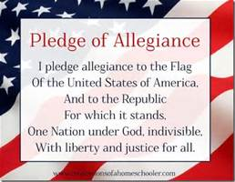
**HILLIE DODGEBALL TOURNAMENT**
The annual Dodgeball Tournament is back!
When: Tuesday, November 23rd - 3pm
Where: HHS Gym
Who: All are invited to make a team & enter the tournament

To sign up your team come get a sign-up sheet in room 205 from Mrs. Harrison or Mrs. Aiello. $50 to enter (5 pp)
Don't want to play? Spectators welcome - $5 entry - pay at the door.

**ALL PROCEEDS GO TO THE CLASS OF 2023**

If you have any questions you can come to room 205!

The GSA club meetings are now being held every Thursday after school until 3:40 in room M23.

The Drama club and Fine Arts Academy is excited to host auditions for our winter one acts. All are welcome, no prior experience is necessary. Auditions will take place in the HHS Auditorium after school today and tomorrow from 2:15 - 4:15. Pick up an audition packet from Mrs. Allen in room A4 or if you have additional questions.

Fashion Club will meet today after school in A15.
Thank you, I hope everyone has a nice day!

