Announcements

Good morning. It is Thursday, September 9, 2021

Please pause for a brief moment of silence…

Please rise for the Pledge of Allegiance…

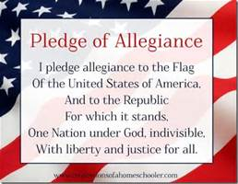
__________________________________________________________________

Let's keep our Hillie community safe and healthy with masking and social distancing! All scholars and staff are required to wear a mask at all times over your nose and mouth while you are inside the building, and keep 3 feet of social distance between yourself and those around you. It takes all of us, and we're in this together, Hillie Nation!
The HHS Drama Club is holding auditions for our fall play, Our Town today, September 8th, from 2:15-3:15. All are welcome, no experience is necessary to audition. Please see Mrs. Allen for an audition packet in room A4 if you would like to audition.

The Diversity Mural Committee will be meeting in Room M20 Thursday 9/9 at 2:05. We will be discussing mural ideas, placement, and timetable for starting for the murals. All who are interested are welcomed to attend

Have a nice day!

