CHORUS
&
DRAMA CLUB
DATES
2015 – 2016
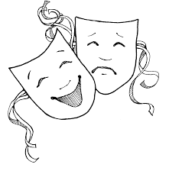
NHS INDUCTION
9/10 (Auditorium, 6:00)

9/11 CEREMONY
9/11 (HHS Quad, Period 2)

BONFIRE RALLY
10/8 (National Anthem)

ACADEMY NIGHT
10/15 (5:30-7:00)

YMCA TEACHER OF THE YEAR
10/16 (DiBurros, 5:30)

SENIOR CLASS PLAY – “DEATHTRAP”
11/20 – 11/22

FESTIVAL OF TREES
11/27 (Buttonwoods Museum 6:00-8:00pm)

EIGHTH GRADE ORIENTATIONS
December - TBD

SOUP KITCHEN CAROLING
12/5 (Universalist Unitarian Church, 3:00-5:00)

MAYOR’S CHRISTMAS PARTY
December - TBD

CHRISTMAS CONCERT
12/17 (Auditorium, ca. 9:30am)

“A CHRISTMAS CAROL”
12/17 – 12/19

MUSICAL – “SOUND OF MUSIC”
3/17 – 3/19

SENIOR SCHOLARSHIP NIGHT
May - TBD

ALL-CITY ART SHOW
May - TBD

BANQUET
Tentatively 5/17

R. ELAINE CROSTON POETRY READING CONTEST
5/27

SENIOR LAST CHAPEL
6/1???

GRADUATION
6/3

